Steps to create V-NET peering using Azure Portal.

**REQUIREMENTS**

* Azure Subscription
* Azure VMs & Virtual Networks

**ENVIRONMENT OVERVIEW**

* We have created two virtual networks named **Virtual-Net-one** and **Virtual-Net-two** for this demo.

[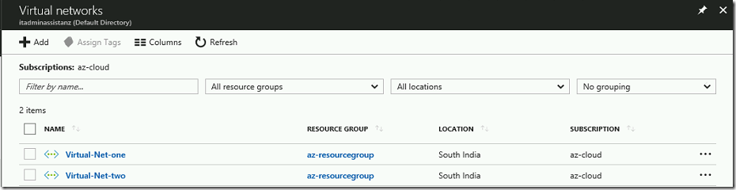](https://www.assistanz.com/wp-content/uploads/2017/12/image.png)

* Also, we set the address space range as **10.0.0.0/16** for Virtual-Net-one and **192.168.0.0/16** for Virtual-Net-two.

[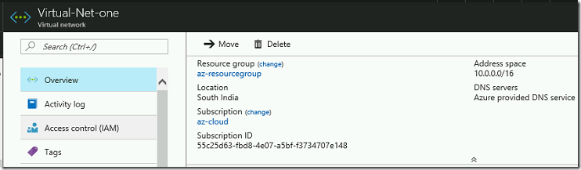](https://www.assistanz.com/wp-content/uploads/2017/12/image-1.png)

[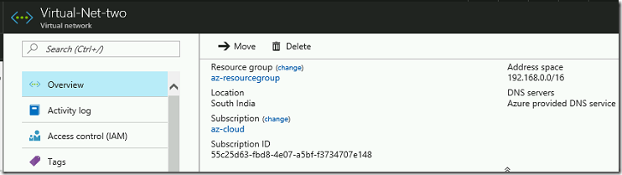](https://www.assistanz.com/wp-content/uploads/2017/12/image-2.png)

* The subnet range for Virtual-Net-one is **10.0.0.0/24** and the Virtual-Net-two range is **192.168.8.0/24**.

[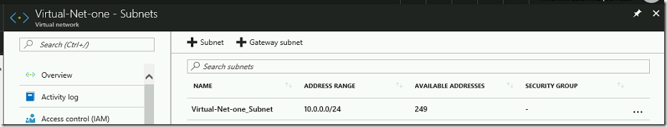](https://www.assistanz.com/wp-content/uploads/2017/12/image-3.png)

[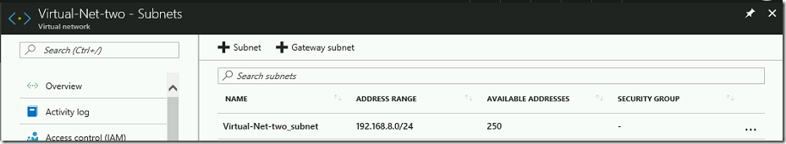](https://www.assistanz.com/wp-content/uploads/2017/12/image-4.png)

* Also, we have configured a jump server to access the VM’s under these networks.

[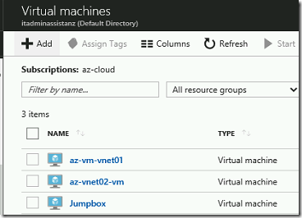](https://www.assistanz.com/wp-content/uploads/2017/12/image-5.png)

**THINGS TO KEEP IN MIND**

* VNETs are isolation boundaries and there is **no default routing** is available between two virtual networks. We need to override this problem.
* We can create a VNET-VNET VPN between two virtual networks.
* Another way to link VNETs are through **VNET Peering**. It is easy to configure without VPN Gateway.
* Make sure that your IP address ranges do not conflict with other virtual networks.
* VNETs should be in the **same Azure region**.
* This option is **less secure** compared to the VPN connection.

**CONFIGURING V-NET PEERING**

* Open the **Virtual-Net-one** network and select **peerings** link.

[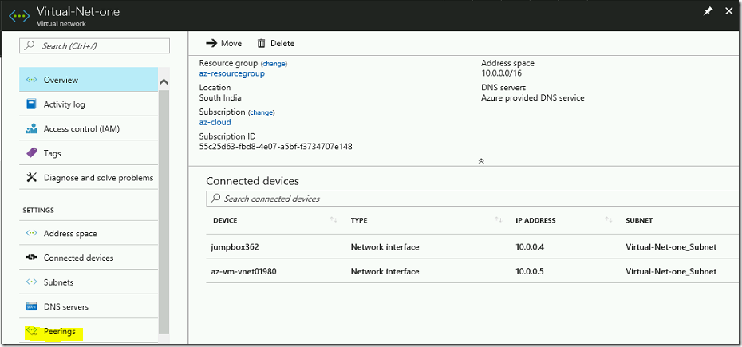](https://www.assistanz.com/wp-content/uploads/2017/12/image-6.png)

* Click on Add button.

[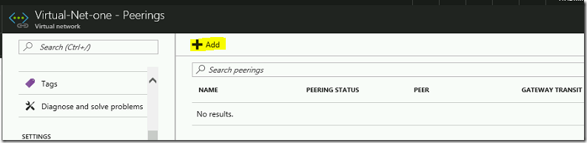](https://www.assistanz.com/wp-content/uploads/2017/12/image-7.png)

* Provide a name, Resource Manager, Subscription, and Virtual Network details. Then click OK.

[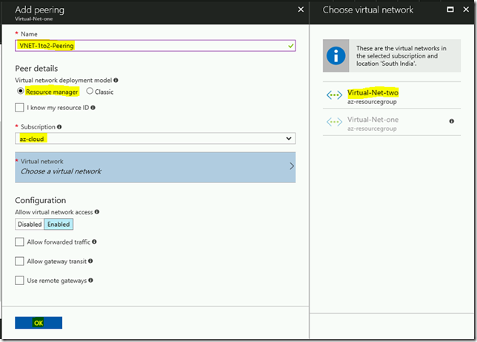](https://www.assistanz.com/wp-content/uploads/2017/12/image-8.png)

* New peering is available on the list.

[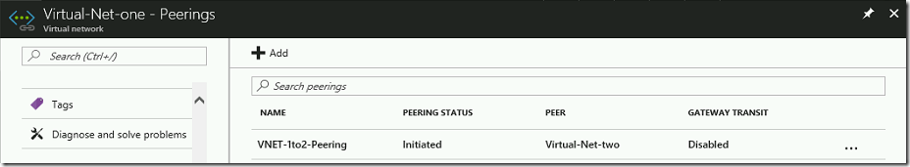](https://www.assistanz.com/wp-content/uploads/2017/12/image-9.png)

* We need to follow the same above steps for **Virtual-Net-two** network.

[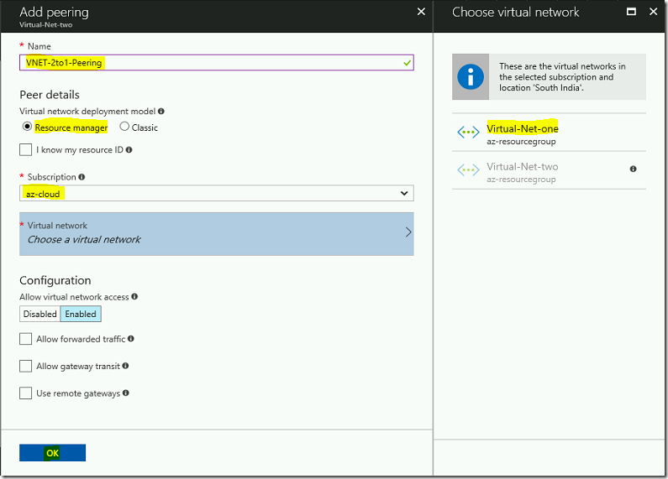](https://www.assistanz.com/wp-content/uploads/2017/12/image-10.png)

* The new peering will be created and peering status is set as **connected**.

[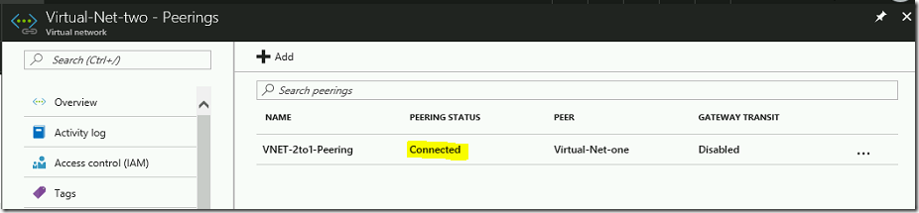](https://www.assistanz.com/wp-content/uploads/2017/12/image-11.png)

**VERIFICATION**

* Login to the jump server named jumpbox and try to ping the **az-vnet02-vm IP 192.168.8.4.**

[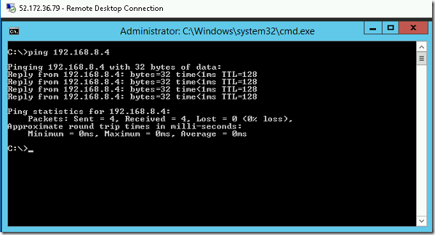](https://www.assistanz.com/wp-content/uploads/2017/12/image-12.png)

* Also, we are able to access the test website which was hosted on **az-vnet02-vm.**

[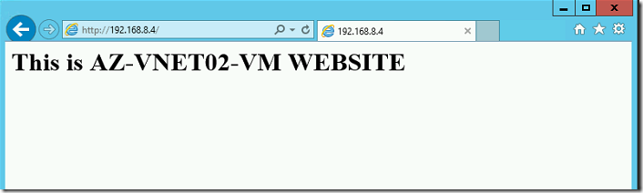](https://www.assistanz.com/wp-content/uploads/2017/12/image-13.png)